N5K VPC功能配置及测试

2013年01月

目 录
一、概述 3
1.1 测试目的 3
1.2测试环境： 3
1.3配置前准备 4
1.3.1配置管理地址 4
1.3.2安装存储license 4
1.3.2N5K操作系统升级 4
三、vPC功能测试 5
3.1 测试目的 5
3.2 测试拓扑 6
3.3 测试配置 6
3.4测试结果 7
四、vPC兼容性测试 11
4.1 测试目的 11
4.2 测试拓扑 11
4.3 测试配置 11
4.4测试结果 12
五、EvPC功能测试 15
5.1 测试目的 15
5.2 测试拓扑 16
5.3 测试配置 16
5.4测试结果 17

一、概述

1.1 测试目的
Nexus 5500交换机作为业界第一款统一端口交换机，同时支持ethernet、 Fibre Channel和Fibre Channel over Ethernet (FCOE)协议。本次测试的目的是为了测试Nexus 5500交换机的功能，以验证是否适合作为服务器区的汇聚交换机，同时实现服务器区的以太网汇聚和SAN存储汇聚，从而逐渐向两网融合的方向演进。.

1.2测试环境：
- 主机：1台IBM P550
- 系统：AIX
- FC HBA：emulex 4Gb double-port
- 盘柜：HDS 2300
- 网络设备：两台Nexus 5596，一台Nexus 2148，一台Nexus 2248，一台Catalyst 3560G
以下是这次测试方案的拓扑。
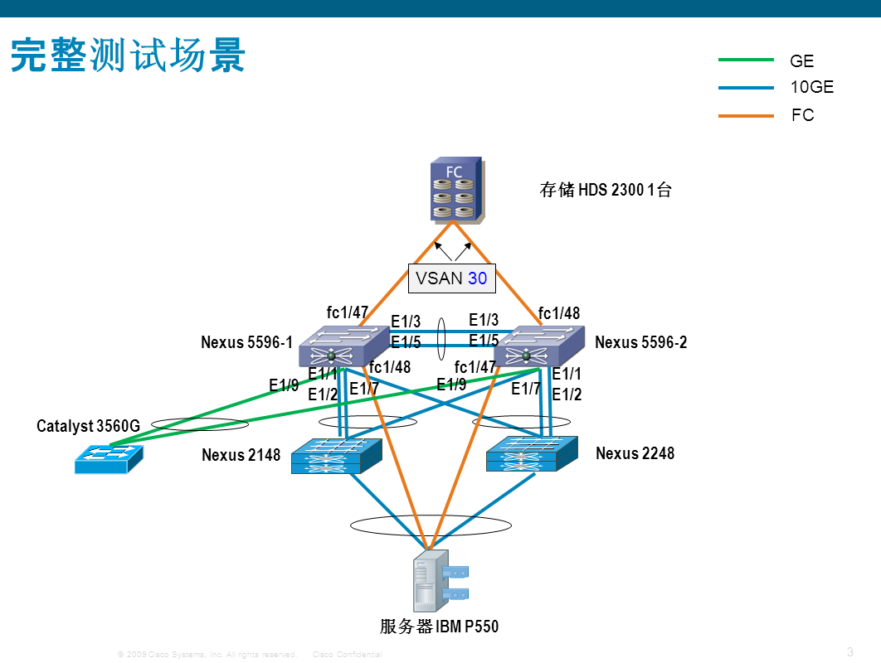

1.3配置前准备

1.3.1配置管理地址
通过Console线连接到两台Nexus 5596的管理口上，分别配置两台设备的管理IP地址在同一网段。在本例中Nexus 5596-1的管理ip是168.7.63.11，Nexus 5596-2的管理ip是168.7.63.12。如下图所示，管理站和A、B控制器正常连接。
配置内容 | 备注
N5596-1  interface mgmt0  ip address 168.7.63.11/25  vrf context management  ip route 0.0.0.0/0 168.7.63.126 | 网管接口放在单独的管理VRF里，避免数据流量的干扰
N5596-2  interface mgmt0  ip address 168.7.63.12/25  vrf context management  ip route 0.0.0.0/0 168.7.63.126 | 网管接口放在单独的管理VRF里，避免数据流量的干扰

1.3.2安装存储license
缺省情况下，N5K没有安装存储license。需要通过思科网站申请临时license。申请步骤如下：
配置内容 | 备注
以N5596-1为例  switch# show license host-id  License hostid: VDH=FOX1513GHGZ  copy tftp://168.7.63.33/test.lic bootflash:test.lic vrf management  install license bootflash:test.lic | 到思科网站www.cisco.com/go/license申请N5K的FCOE license，申请后更改license名字（不能太长）。  将license文件拷贝到flash中。由于是通过管理口拷贝，所以要加上vrf参数。  安装存储license。

1.3.2N5K操作系统升级
在测试前需要升级N5K的操作系统。
配置内容 | 备注
以N5596-1为例  copy tftp:// n5000-uk9-kickstart.5.1.3.N1.1a.bin bootflash: n5000-uk9-kickstart.5.1.3.N1.1a.bin  copy tftp:// n5000-uk9.5.1.3.N1.1a.bin bootflash: n5000-uk9.5.1.3.N1.1a.bin  Install all | 操作系统升级包括kickstart和system两个image。  把kickstart image拷进bootflash  。  将system image文件拷进bootflash  升级操作系统

三、vPC功能测试

3.1 测试目的
虚拟端口捆绑技术vPC(Virtual Port-Channel)是一种扩展技术，它通过将两个交换机的转发平面整合，实现接入设备采用Port-Channel同时上联两个汇聚交换机，实现双倍的聚合带宽，并消除STP blocked ports，在link/device失效下提供快速收敛。采用板卡延伸技术和vPC技术，可以有效扩展网络规模，同时减少生成树对于网络的影响。
传统端口信道通信的最大限制在于端口信道只能在两个设备之间运行。在大型网络中，设计中常常需要同时支持多个设备，来提供某些形式的硬件故障备用路径。这一备用路径的连接方式常常会导致环路，从而限制对单一路径实施端口信道技术的优势。为突破此限制，Cisco NX-OS软件平台提供一种名为虚拟端口捆绑组，或即 vPC 的技术。尽管对于与端口信道相连的设备来说，一对作为 vPC 对等终端的交换机就像是单一逻辑实体，但这两个作为逻辑端口信道终端的设备仍是两个独立设备。该环境结合了硬件冗余性和端口信道环路管理的优势。升级到一个完全基于端口信道的环路管理机制，所能获得的另一主要优势是，链路恢复速度大大加快。生成树协议从链路故障中恢复的时间大约为6秒，而完全基于虚拟端口捆绑组vPC的解决方案则有可能在不到 1 秒能完成故障恢复。
vPC为第二层网络提供大量重要优势，并借助第二层功能提供的优势，对第三层互联进行一系列改进。
在第二层网络中，能够实现以下优势：
● 通过冗余系统提高系统可用性
● 无需使用生成树协议，即能进行环路管理
● 始终提供完全系统带宽可用性
● 迅速恢复链路故障
● 为任意支持 IEEE 802.3ad 的边缘设备提供端口信道连接
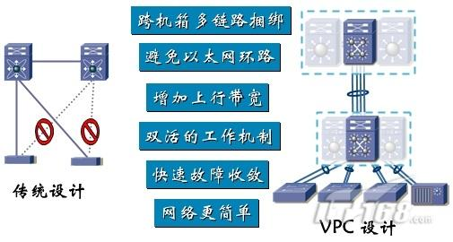

本项测试的目的是验证vPC技术。

3.2 测试拓扑
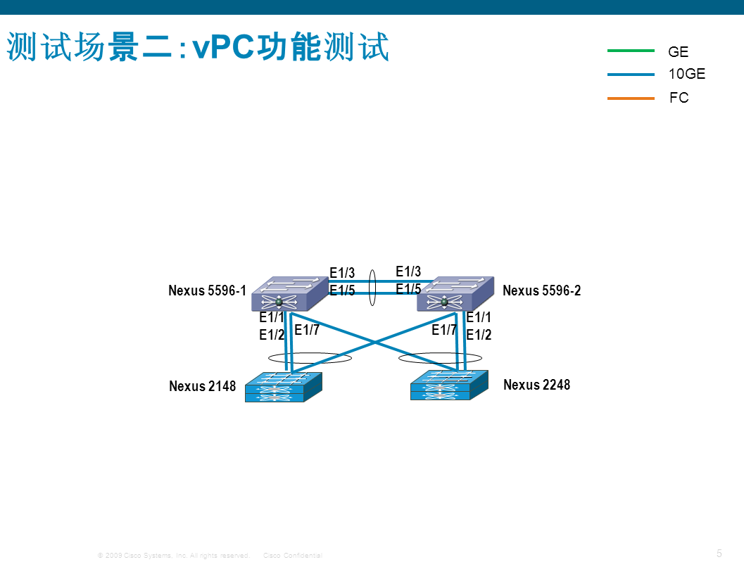
将两台Nexus 2000设备与两台Nexus 5596交叉连接，验证两台Nexus 5596上是否都能认到两台Nexus 2000设备。

3.3 测试配置
配置内容 | 备注
N5596-1  feature vpc  vpc domain 3  peer-keepalive destination 168.7.63.12  interface port-channel230  switchport mode trunk  spanning-tree port type network  speed 10000  vpc peer-link  interface Ethernet1/3  switchport mode trunk  channel-group 230 mode active  interface Ethernet1/5  switchport mode trunk  channel-group 230 mode active  interface port-channel100  vpc 100  interface port-channel132  switchport mode fex-fabric  fex associate 132  vpc 132  interface Ethernet1/7  switchport mode fex-fabric  fex associate 132  channel-group 132 | ；启用vpc  ；创建vPC域，分配域ID  ；将管理口连接用作peer keepalive link  ；两台N5K互联的portchannel  ；  ；  ；  ；将互联接口用作peer link  ；将与下联设备N2148T相连的portchannel接口放到vpc域中，分配的数字应与N5596-2相同  ；增加与N2248TP相连的配置，与N5596-2上的配置基本相同  ；与N2248TP相连的接口
N5596-2

feature vpc
vpc domain 3
peer-keepalive destination 168.7.63.11
interface port-channel230
switchport mode trunk
spanning-tree port type network
speed 10000
vpc peer-link
interface Ethernet1/3
switchport mode trunk
channel-group 230 mode active
interface Ethernet1/5
switchport mode trunk
channel-group 230 mode active
interface port-channel132
vpc 132
interface port-channel100
switchport mode fex-fabric
fex associate 100
vpc 100
interface Ethernet1/7
switchport mode fex-fabric
fex associate 100
channel-group 100

3.4测试结果
配置内容 | 备注
N5596-1  n5596-1# show fex  FEX FEX FEX FEX  Number Description State Model Serial  ------------------------------------------------------------------------  100 FEX0100 Online N2K-C2148T-1GE FOX1316GD83  132 FEX0132 Online N2K-C2248TP-1GE SSI141904Y2  n5596-1#show run  。。。。。。。。。。。。。  interface Ethernet100/1/1  interface Ethernet100/1/2  interface Ethernet100/1/3  。。。。。。。。。。。。。  interface Ethernet132/1/1  interface Ethernet132/1/2  interface Ethernet132/1/3  。。。。。。。。。。。。。  n5596-1# show port-channel database  port-channel100  Last membership update is successful  2 ports in total, 2 ports up  First operational port is Ethernet1/1  Age of the port-channel is 27d:15h:30m:25s  Time since last bundle is 27d:15h:31m:25s  Last bundled member is Ethernet1/2  Ports: Ethernet1/1 [on] [up] *  Ethernet1/2 [on] [up]  port-channel132  Last membership update is successful  1 ports in total, 1 ports up  First operational port is Ethernet1/7  Age of the port-channel is 27d:15h:30m:25s  Time since last bundle is 14d:18h:01m:33s  Last bundled member is Ethernet1/7  Ports: Ethernet1/7 [on] [up] *  port-channel230  Last membership update is successful  2 ports in total, 2 ports up  First operational port is Ethernet1/3  Age of the port-channel is 14d:18h:08m:51s  Time since last bundle is 14d:18h:08m:46s  Last bundled member is Ethernet1/5  Ports: Ethernet1/3 [active ] [up] *  Ethernet1/5 [active ] [up]  n5596-1# show vpc brief  Legend:  (*) - local vPC is down, forwarding via vPC peer-link  vPC domain id : 3  Peer status : peer adjacency formed ok  vPC keep-alive status : peer is alive  Configuration consistency status: success  Per-vlan consistency status : success  Type-2 consistency status : success  vPC role : secondary, operational primary  Number of vPCs configured : 100  Peer Gateway : Disabled  Dual-active excluded VLANs : -  Graceful Consistency Check : Enabled  vPC Peer-link status  ---------------------------------------------------------------------  id Port Status Active vlans  -- ---- ------ --------------------------------------------------  1 Po230 up 1,10,50,150,300  vPC status  ----------------------------------------------------------------------------  id Port Status Consistency Reason Active vlans  ------ ----------- ------ ----------- -------------------------- -----------  100 Po100 up success success -  132 Po132 up success success -  101377 Eth100/1/1 down* Not Consistency Check Not -  Applicable Performed  。。。。。。。。。。。。。。。。。。。。。。。。。。。。。。。。。。。。。。 | ；两个fex都已经正常连接  ；配置中出现了两个FEX的接口  ；portchannel100处于正常状态，包含和N2148T相连的e1/1和e1/2两个接口  ；portchannel132处于正常状态，包含和N2248TP相连的e1/7接口  ；portchannel230处于正常状态，包含两台N5K互联的e1/3和e1/5两个接口  ；vPC 100状态正常  ；Vpc 132状态正常
N5596-2

n5596-2# show fex
FEX FEX FEX FEX
Number Description State Model Serial
------------------------------------------------------------------------
100 FEX0100 Online N2K-C2148T-1GE FOX1316GD83
132 FEX0132 Online N2K-C2248TP-1GE SSI141904Y2

n5596-2#show run
。。。。。。。。。。。。。
interface Ethernet100/1/1
interface Ethernet100/1/2
interface Ethernet100/1/3
。。。。。。。。。。。。。
interface Ethernet132/1/1
interface Ethernet132/1/2
interface Ethernet132/1/3
。。。。。。。。。。。。。

n5596-2# show port-channel database
port-channel100
Last membership update is successful
1 ports in total, 1 ports up
First operational port is Ethernet1/7
Age of the port-channel is 13d:21h:39m:23s
Time since last bundle is 13d:21h:40m:22s
Last bundled member is Ethernet1/7
Ports: Ethernet1/7 [on] [up] *

port-channel132
Last membership update is successful
2 ports in total, 2 ports up
First operational port is Ethernet1/1
Age of the port-channel is 13d:21h:39m:23s
Time since last bundle is 13d:21h:40m:22s
Last bundled member is Ethernet1/2
Ports: Ethernet1/1 [on] [up] *
Ethernet1/2 [on] [up]

port-channel230
Last membership update is successful
2 ports in total, 2 ports up
First operational port is Ethernet1/3
Age of the port-channel is 13d:21h:39m:23s
Time since last bundle is 13d:21h:40m:22s
Last bundled member is Ethernet1/5
Ports: Ethernet1/3 [active ] [up] *
Ethernet1/5 [active ] [up]

n5596-1# show vpc brief
Legend:
(*) - local vPC is down, forwarding via vPC peer-link

vPC domain id : 3
Peer status : peer adjacency formed ok
vPC keep-alive status : peer is alive
Configuration consistency status: success
Per-vlan consistency status : success
Type-2 consistency status : success
vPC role : primary, operational secondary
Number of vPCs configured : 100
Peer Gateway : Disabled
Dual-active excluded VLANs : -
Graceful Consistency Check : Enabled

vPC Peer-link status
---------------------------------------------------------------------
id Port Status Active vlans
-- ---- ------ --------------------------------------------------
1 Po230 up 1,10,50,150,300

vPC status
----------------------------------------------------------------------------
id Port Status Consistency Reason Active vlans
------ ----------- ------ ----------- -------------------------- -----------
100 Po100 up success success -
132 Po132 up success success -
101377 Eth100/1/1 down* Not Consistency Check Not -
Applicable Performed
。。。。。。。。。。。。。。。。。。。。。。。。。。。。。。。。。。。。。。

vPC功能工作正常。

四、vPC兼容性测试

4.1 测试目的
在vPC的部署场景中，接入设备的选择是一个重要的考虑因素。N2K FEX设备作为N5K设备的扩展板卡，支持vPC。但是接入设备也可能选择比较便宜的传统以太网接入交换机，例如Catalyst 2960。
本项测试的目的是验证vPC技术对于传统的以太网接入交换机同样适用。

4.2 测试拓扑
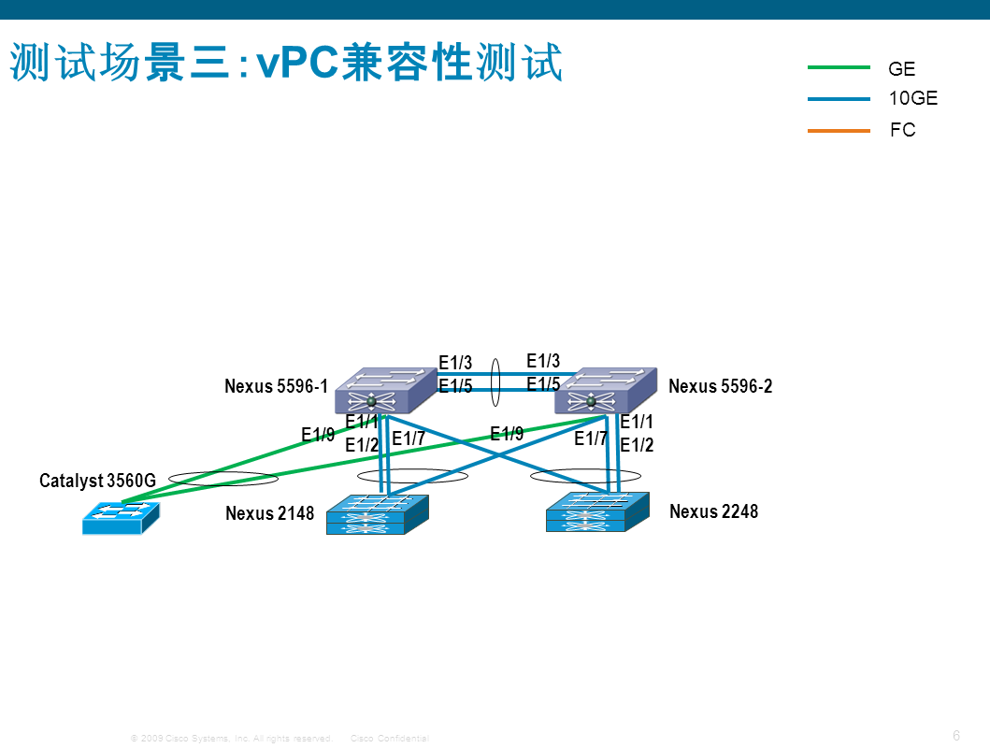
将Catalyst 3560G的两个SFP上联接口分别与两台Nexus 5596连接，验证Catalyst 3560G上可以实现跨机箱的链路捆绑。

4.3 测试配置
配置内容 | 备注
N5596-1  feature interface-vlan  interface Vlan300  no shutdown  management  ip address 10.48.50.202/24  interface port-channel20  switchport mode trunk  speed 1000  vpc 20  interface Ethernet1/9  switchport mode trunk  speed 1000  channel-group 20 mode active | ；支持在vlan接口上配置IP地址  ；为与接入交换机相连的portchannel口分配vpc号  ；N5K上插千兆SFP时需手动指定速率
N5596-2

feature interface-vlan
interface Vlan300
no shutdown
management
ip address 10.48.50.132/24
interface port-channel20
switchport mode trunk
speed 1000
vpc 20
interface Ethernet1/9
switchport mode trunk
speed 1000
channel-group 20 mode active
Catalyst 3560G

interface GigabitEthernet0/27
switchport mode trunk
channel-group 20 mode active
interface GigabitEthernet0/28
switchport mode trunk
channel-group 20 mode active
interface port-channel20
switchport mode trunk
interface Vlan300
no shutdown
ip address 10.48.50.168

4.4测试结果
配置内容 | 备注
N5596-1  n5596-1# show port-channel database  port-channel20  Last membership update is successful  1 ports in total, 0 ports up  Age of the port-channel is 14d:17h:46m:34s  Time since last bundle is 14d:17h:46m:34s  Last bundled member is Ethernet1/9  Ports: Ethernet1/9 [active ] [individual]  n5596-1# show vpc brief  Legend:  (*) - local vPC is down, forwarding via vPC peer-link  vPC domain id : 3  Peer status : peer adjacency formed ok  vPC keep-alive status : peer is alive  Configuration consistency status: success  Per-vlan consistency status : success  Type-2 consistency status : success  vPC role : secondary, operational primary  Number of vPCs configured : 100  Peer Gateway : Disabled  Dual-active excluded VLANs : -  Graceful Consistency Check : Enabled  vPC Peer-link status  ---------------------------------------------------------------------  id Port Status Active vlans  -- ---- ------ --------------------------------------------------  1 Po230 up 1,10,50,150,300  vPC status  ----------------------------------------------------------------------------  id Port Status Consistency Reason Active vlans  ------ ----------- ------ ----------- -------------------------- -----------  20 Po20 up success success -。。。。。。。。。。。。。。。。。。。。。。。。。。。。。。。。。。。。。。  n5596-1# show int po20  port-channel20 is up  vPC Status: up, vPC number: 20  Hardware: Port-Channel, address: 547f.ee07.3510 (bia 547f.ee07.3510)  MTU 1500 bytes, BW 1000000 Kbit, DLY 10 usec  reliability 255/255, txload 1/255, rxload 1/255  Encapsulation ARPA  Port mode is trunk  auto-duplex, 1000 Mb/s  Input flow-control is off, output flow-control is off  Switchport monitor is off  EtherType is 0x8100  Members in this channel: Eth1/9  Last clearing of "show interface" counters never  30 seconds input rate 2328 bits/sec, 3 packets/sec  30 seconds output rate 904 bits/sec, 1 packets/sec | ；portchannel 20正常  ；vPC 20状态正常  ；portchannel20接口up
N5596-2

n5596-2# show port-channel database
port-channel20
Last membership update is successful
1 ports in total, 0 ports up
Age of the port-channel is 13d:21h:39m:23s
Time since last bundle is 13d:21h:40m:22s
Last bundled member is Ethernet1/9
Ports: Ethernet1/9 [active ] [individual]

n5596-2# show vpc brief
Legend:
(*) - local vPC is down, forwarding via vPC peer-link

vPC domain id : 3
Peer status : peer adjacency formed ok
vPC keep-alive status : peer is alive
Configuration consistency status: success
Per-vlan consistency status : success
Type-2 consistency status : success
vPC role : primary, operational secondary
Number of vPCs configured : 100
Peer Gateway : Disabled
Dual-active excluded VLANs : -
Graceful Consistency Check : Enabled

vPC Peer-link status
---------------------------------------------------------------------
id Port Status Active vlans
-- ---- ------ --------------------------------------------------
1 Po230 up 1,10,50,150,300

vPC status
----------------------------------------------------------------------------
id Port Status Consistency Reason Active vlans
------ ----------- ------ ----------- -------------------------- -----------
20 Po20 up success success -。。。。。。。。。。。。。。。。。。。。。。。。。。。。。。。。。。。。。。

n5596-2# show int po20
port-channel20 is up
vPC Status: up, vPC number: 20
Hardware: Port-Channel, address: 547f.ee07.3510 (bia 547f.ee07.3510)
MTU 1500 bytes, BW 1000000 Kbit, DLY 10 usec
reliability 255/255, txload 1/255, rxload 1/255
Encapsulation ARPA
Port mode is trunk
auto-duplex, 1000 Mb/s
Input flow-control is off, output flow-control is off
Switchport monitor is off
EtherType is 0x8100
Members in this channel: Eth1/9
Last clearing of "show interface" counters never
30 seconds input rate 2280 bits/sec, 3 packets/sec
30 seconds output rate 1008 bits/sec, 1 packets/sec
Catalyst 3560G  Show interface po20 | ；portchannel接口正常  ；拔掉一个上联端口，PING不丢包

vPC与普通以太网交换机配合工作正常。

五、EvPC功能测试

5.1 测试目的
EvPC即增强vPC或者双层vPC。在EvPC的部署场景中，不仅接入设备可以跨N5K进行链路捆绑，而且服务器做NIC TEAMING的时候也可以跨不同接入设备做loadbalance，而不仅仅是Active-Standby。支持EvPC的接入设备只能是N2K，而不能是普通的以太网交换机。
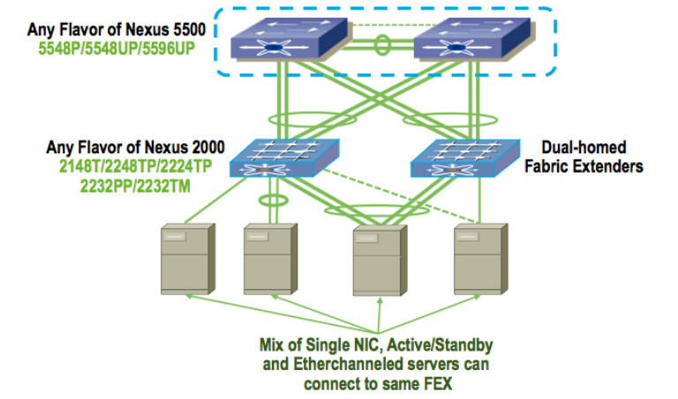
本项测试的目的是验证EvPC技术。

5.2 测试拓扑
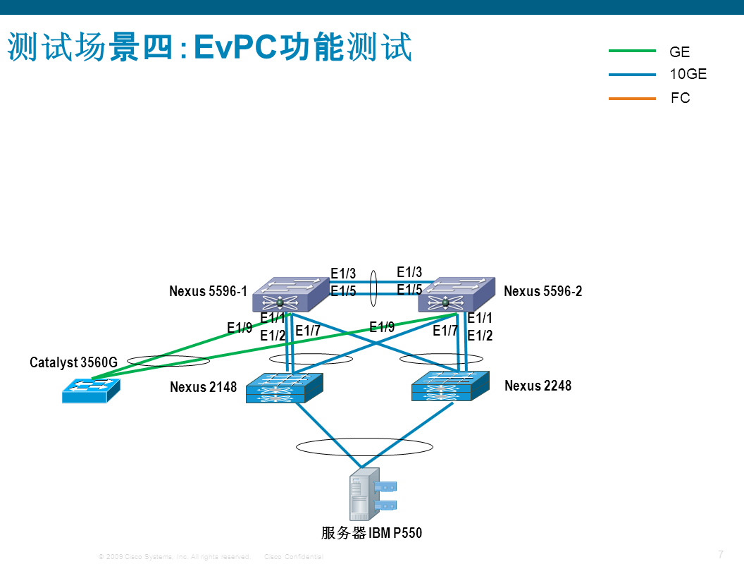
将服务器IBM P550的两个以太网口分别连接到Nexus 2148T和Nexus 2248TP，配置NIC teaming为loadbalance模式，验证NIC teaming是否正常。

5.3 测试配置
配置内容 | 备注
N5596-1  interface port-channel3  switchport access vlan 300  interface Ethernet100/1/1  switchport access vlan 300  channel-group 3  interface Ethernet132/1/1  switchport access vlan 300  channel-group 3 | ；两台N5K的Portchannel号必须一样  ；EvPC不需要手动分配vPC号，系统内部会自动分配  ；对同一个FEX端口的配置，两台N5K上必须完全一样，否则FEX端口无法正常工作
N5596-2

interface port-channel3
switchport access vlan 300
interface Ethernet100/1/1
switchport access vlan 300
channel-group 3
interface Ethernet132/1/1
switchport access vlan 300
channel-group 3

5.4测试结果
配置内容 | 备注
N5596-1  n5596-1(config-if)# show int po3  port-channel3 is up  vPC Status: Up, vPC number: 262146  Hardware: Port-Channel, address: 5475.d0e8.c042 (bia 5475.d0e8.c042)  MTU 1500 bytes, BW 1000000 Kbit, DLY 10 usec  reliability 255/255, txload 1/255, rxload 1/255  Encapsulation ARPA  Port mode is access  full-duplex, 1000 Mb/s  Input flow-control is off, output flow-control is on  Switchport monitor is off  EtherType is 0x8100  Members in this channel: Eth100/1/1, Eth132/1/1  Last clearing of "show interface" counters never  30 seconds input rate 28560 bits/sec, 35 packets/sec  30 seconds output rate 28632 bits/sec, 35 packets/sec  Load-Interval #2: 5 minute (300 seconds)  input rate 2.78 Kbps, 3 pps; output rate 2.99 Kbps, 3 pps  RX  2379 unicast packets 1 multicast packets 100 broadcast packets  2480 input packets 198316 bytes  0 jumbo packets 0 storm suppression bytes  0 runts 0 giants 0 CRC 0 no buffer  0 input error 0 short frame 0 overrun 0 underrun 0 ignored  0 watchdog 0 bad etype drop 0 bad proto drop 0 if down drop  0 input with dribble 0 input discard  0 Rx pause  TX  2623 unicast packets 146511 multicast packets 2376 broadcast packets  151510 output packets 38551096 bytes  0 jumbo packets  0 output errors 0 collision 0 deferred 0 late collision  0 lost carrier 0 no carrier 0 babble 2 output discard  0 Tx pause | ；vPC状态正常，vPC号自动分配
N5596-2

n5596-2# show int po3
port-channel3 is up
vPC Status: Up, vPC number: 262146
Hardware: Port-Channel, address: 5475.d0e8.c042 (bia 5475.d0e8.c042)
MTU 1500 bytes, BW 1000000 Kbit, DLY 10 usec
reliability 255/255, txload 1/255, rxload 1/255
Encapsulation ARPA
Port mode is access
full-duplex, 1000 Mb/s
Input flow-control is off, output flow-control is on
Switchport monitor is off
EtherType is 0x8100
Members in this channel: Eth100/1/1, Eth132/1/1
Last clearing of "show interface" counters never
30 seconds input rate 0 bits/sec, 0 packets/sec
30 seconds output rate 144 bits/sec, 0 packets/sec
Load-Interval #2: 5 minute (300 seconds)
input rate 0 bps, 0 pps; output rate 112 bps, 0 pps
RX
2380 unicast packets 1 multicast packets 100 broadcast packets
2481 input packets 198380 bytes
0 jumbo packets 0 storm suppression bytes
0 runts 0 giants 0 CRC 0 no buffer
0 input error 0 short frame 0 overrun 0 underrun 0 ignored
0 watchdog 0 bad etype drop 0 bad proto drop 0 if down drop
0 input with dribble 0 input discard
0 Rx pause
TX
2624 unicast packets 146527 multicast packets 2376 broadcast packets
151527 output packets 38555566 bytes
0 jumbo packets
0 output errors 0 collision 0 deferred 0 late collision
0 lost carrier 0 no carrier 0 babble 8 output discard
0 Tx pause
4 interface resets
IBM P550

将网卡地址配置为10.48.50.218，PING N5596-1的vlan 300接口地址10.48.50.132，将连接N2148T的e100/1/1接口拔掉，不丢包，证明portchannel生效。

EvPC功能工作正常。

